Blog for Babies!
Become a Baby’s First Test Blogger Today!
Have you ever imagined making a difference and helping babies with your blog? You can by using your blog to become a Baby’s First Test blogger. Being a Baby’s First Test blogger can take only a few moments, or if you have more time to commit, your help is certainly needed!
Anxious to get started? Simply do one, two, or all of the following, whatever your time and skills allow.
- Put this badge on your sidebar to show your readers you support Baby’s First Test.
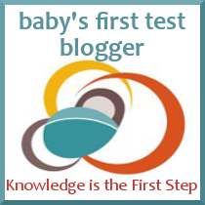
- Write a blog post about your newborn screening experience and link back to Baby’s First Test. If you’re pregnant, use Baby’s First Test to answer any of your questions and then link back to the resource sections you used. Wondering what your state screens for? Curious about how your baby will be screened? You can find answers to those questions (and many more) on Baby’s First Test, and then share with your readers.
- Use those social networks! Your Twitter account can be a real lifesaver, share www.babysfirsttest.org with your followers, and follow @BabysFirstTest on Twitter.
- Reach out to other bloggers and tell them about the resources available in this toolkit to use their blogs for a good cause.
- Host a link-up for newborn screening and encourage your blogging buddies to post and link up to your blog.
Remember to tell us what you’re doing! We’d love to help and support your efforts. Leave a comment below or use our contact form to get in touch.

